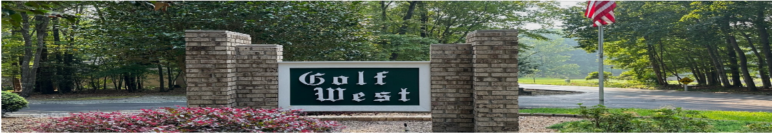
November 6, 2025 Golf West POA Annual Meeting
- Executive Summary
- 2026 budget approved unanimously with $34/lot increase for common grounds upkeep due to landscaping contractor expansion (Gene Jeremiah retired, no volunteer replacement); total capital reserve will reach $60,805.12 after collecting $22,500 in 2026.
- Upper culvert and Fairway Woods turnaround completed for $63,838 funded from matured CDs with no special assessment; lower culvert replacement planned in 2–3 years, followed by mill-and-resurface of all roads.
- Carolina Water Service proposed 49% rate increase; CTA approved petition to oppose (link via website); partial legal representation option quoted at $30,000 still under debate.
- Two new initiatives launched: bylaws revision committee forming to clarify unclear provisions page-by-page, and sheriff's department community watch presentation being scheduled following vehicle theft on Oct 21 from Laurel Thicket.
- Architecture Committee process corrected after communication breakdown on recent build; new requirement mandates all three members sign off on checklist packet (agree/disagree) before approval, ensuring full transparency and no approvals when members unavailable.
- Full Summary
- Opening & Meeting Procedures
- Eric opened the 2025 annual meeting with procedural instructions
- Blank ballots available with Debbie Betts and Debbie Crenshaw assisting
- Minutes approval foregone due to lack of quorum
- Minutes pre-approved in executive session, posted on website, and distributed to community
- Email correspondence check skipped due to internet outage
- Treasurer's Report & 2025 Financial Review
- Fern Jeremiah presented treasury report as treasurer entering sixth year
- Fiscal year ends October 31st
- Checking account ending balance for 2025: $13,011.53
- Volunteers praised for branch pickup, maintenance, and seasonal decorations
- Gene Jeremiah and Don Berger instrumental in major capital projects
- Capital Projects & Improvements
- Upper culvert installation and turnaround improvement at bottom of Fairway Woods completed
- Total cost: $63,838 funded from accumulated capital reserves in CDs
- No special assessment required
- Legal fees: $1,250 to Sanford Law Group for property access
- CD interest in 2024: $3,934
- IRS tax: $1,150, NC state tax: $96, CPA fees: $600
- Lower culvert replacement needed in 2-3 years
- Long-range plan includes mill and resurfaces of all roads after both culverts replaced
- 2026 Budget Proposal
- Capital reserve held at $22,500 for 2026
- Current total in CDs: $38,305.12
- Will reach $60,805.12 with 2026 capital assessment
- Common grounds upkeep increased by $34 per lot
- Gene Jeremiah retired; no volunteer replacement found
- We Can Do It (Pam Eisman) contracted for additional landscaping services at $125/month
- New scope includes culvert checks, road blowing, ditch blowing, monthly stick pickup
- Equates to $33.33 per lot, rounded to $34/year
- Homeowners must keep their own culverts clear
- Budget approved unanimously by community vote
- CTA Updates & Community Initiatives
- CTA representative absent; Fern Jeremiah read Doug's report
- Hydrilla & Pond Management
- Hydrilla nearly eliminated from lake; Stonegate Pond confirmed hydrilla-free
- Community Safety & Utilities
- Vehicle theft occurred around October 21st from Laurel Thicket
- Ting fiber internet in progress
- Sticking point: five-year contract length at $89/month fixed rate
- Regional Governance & Legal Matters
- Carolina Water Service proposed 49% rate increase
- CTA board approved petition to oppose; available via website
- CTA lawyer consultation options discussed
- Full representation: $10,000
- Partial representation: $30,000
- Recording of Zoom call with lawyer Peter Ledford available
- TRAM sign island signage remains contentious over country club representation
- Committee Reports
- Architecture Committee
- Golf West Member #1 raised communication breakdown on recent house construction
- Architectural request sent to three members; one objected to size, positioning, and setback but didn't communicate to board
- Board remedy: creating checklist packet requiring all committee members to sign off
- Approvals cannot occur if members out of town
- Builder cooperated with modifications without additional cost
- Golf West Member #2 questioned unanimity requirement for three-person committee, suggesting majority rule instead
- Website Development
- Allison Rhyne working on user-friendly website
- Goals include downloadable bylaws, financial reports, and direct email link to Architecture Committee chair
- Social Committee
- Kimberly Wick accepting donations and volunteers
- Strategic Projects & Initiatives
- Community Security Program
- Eric scheduling sheriff's department presentation on community watch
- Would cover warning signs and prevention measures
- Driven by vehicle break-ins and dark areas around lake
- Bylaws Revision Committee
- Bylaws need revamping; Eric forming dedicated committee
- Plan to review page-by-page to identify needed changes
- Committee retreat planned at country club or member's home
- Attorney available to advise on interpretation issues
- Announcements & Community Communications
- Assessment notices will be sent by next week
- Electronic distribution to those with email on file, paper copies mailed to all
- Minutes and financial reports will be emailed and posted on website
- New community members welcomed: Natasha Connelly, Corinne, and Janine (resident since December at 3125)
- Fern Jeremiah maintains open door policy for accounting questions
- Q&A Discussion
- Budget & Financial Questions
- Audit discussion: CPA quote of $8,000 minimum with four-year commitment deemed too expensive
- Alternative: community group with accounting expertise to review books with treasurer
- Transaction volume: 12-20 transactions per year, some months with zero checks written
- Only consistent monthly items: two automatic drafts for electricity and water
- Speaker 1 noted 30 minutes sufficient to review entire year
- Every check requires two signatures for dual control
Eric Badgett closes annual meeting
Respectively Submitted,
Richard Carroll
Golf West POA Secretary

