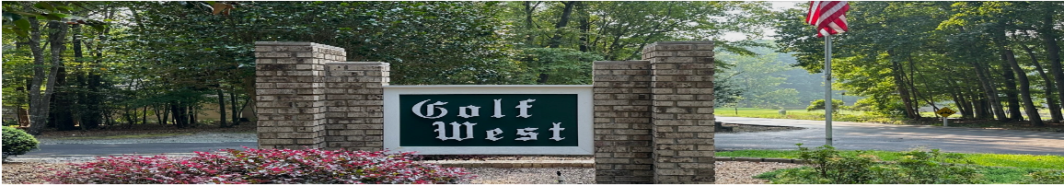

Join Us in Keeping Golf West Beautiful!
🌿 Community Branch Cleanup Day – April 11th at 9 AM 🌿
Golf West residents, let’s come together to help keep our neighborhood clean and beautiful! On Saturday, April 11th at 9 AM, we invite you to join us for a community walk to pick up branches and any trash along the roads, common areas, and empty lots.
Eric Badgett will lead the effort and provide guidance. Simply bring your enthusiasm, we’ll take care of the rest! The collected branches will be placed in piles along the road for the scheduled April 14th pick up and removal.
This is a great opportunity to connect with neighbors and make a positive impact on our community. We’d love to see you there!
📍 Meeting Point: Front Entrance Golf West Sign
💡 What to Bring: Gloves, comfortable shoes, and a willingness to help!
Thank you for pitching in to keep Golf West looking its best! 🌎✨

